**Public security group should allow http, https traffic.**

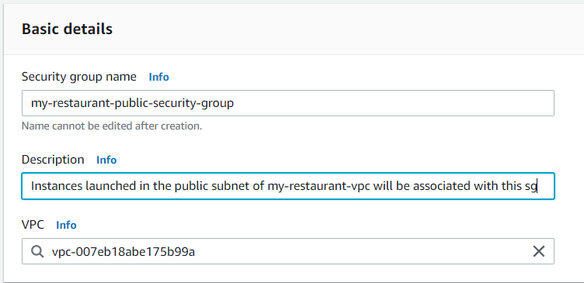

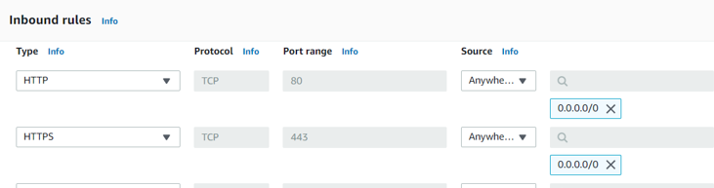

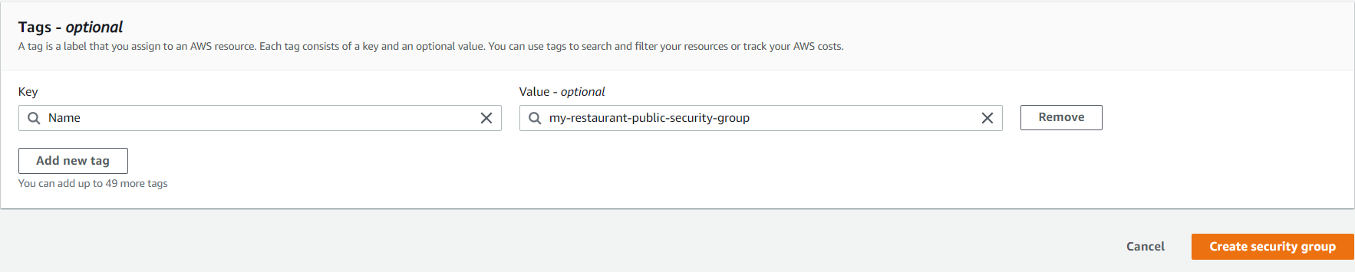

**Private subnet should allow MySQL traffic on port 3306 from the security group of the public subnet only**

